1. **Explain the difference between quality planning, assurance and control.**

Quality plan consists of specifying the quality goals, choose appropriate methods for preventing and detecting the defects, stats any activities would be taken placed during the project. Quality assurance would be focused on preventing fault by series of design and auditing events. However, quality control would just contains the activities of detecting defects and faults during the testing stage.

1. **Explain, from the point of view of software quality, what is the *appraisal cost* and give two examples.**

During software development, there are the events of analysis and evaluating the work done after individual tasks, they are to ensure those works completed to a predefined degree of quality, length of time and any resource and cost incurred during those events taking place are the appraisal cost. For example, a code walk-through would be host by pairs of programmer after completion of some features, a static code analysis report must be generated and programmers would need some times to explain codes to each other. And also, a time taken of daily integration test.

1. **Describe each of the stages of the people Capability Maturity Model: Initial, Repeatable, Defined, Managed and Optimized.**

Initial: the organization has no repeatable process while perform works, no appropriate responsibility assigned to people and they have their own usual practices, and no managed process for managing workforce and poor communication.

Repeatable: the organization has stable work environment and some repeatable work process. Individuals are able to deliver regular work with consistency performance for some tasks, and also have some communications through their works.

Defined: Based on developed the repeatable process, the organization use the individual practices to build organization-wide framework, define the agreement and standard among the workforce. And also, they are have usual strategies plan workforce and analysis their skills and knowledge.

Managed: the organization can manage capability and performance quantitatively. It enables them to take control the work in the quantify way, which would guide them to make reasonable decisions.

Optimized: organization focus on the continuous improvement. They perform change management on regular basis and constantly improve their methods based on the quantitative results.

1. **Describe the type of errors that are detected when “static control flow analysis” is performed in the code.**

The multiple exists of looping and any unreachable codes can be detected.

1. **Consider a function inside a navigational system for a car that receives the current speed as parameter and returns an estimation the gas construction of the vehicle. It applies different estimations for the following speed ranges (in km/h): 10-30, 30-50, 50-80, 80-120. What values would you choose to write black-box tests for such function based on the technique of input equivalence partition?**

Boundary test inputs: 9 and 121

Middle, some normal values test inputs: 60, 30 and 80

Zero length of input test: null

1. Calculate the cyclomatic complexity of the following method:

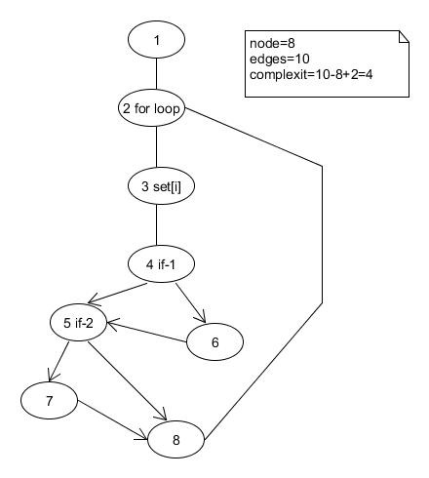

1. What kind of functionality is provided by a test management tool in the area of reporting?

The test progress report could be generated including the coverage of test case for the requirements, the number of test cases pass and failed, the amount of bugs been detected and person who responsible for the bugs.